## **Code for Cross Entropy Loss Function**

What are the changes we need to make in the code

1. Here is the Python code for Gradient Descent with Cross Entropy Loss function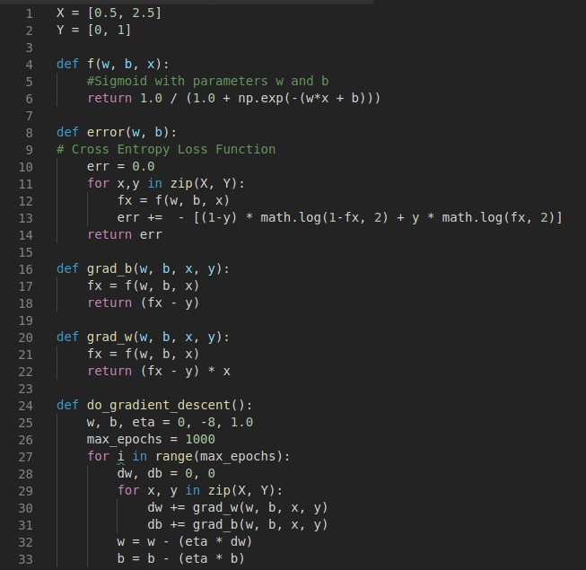
2. Here, the functions f(w, b, x), grad_b(w,b,x,y) and grad_w(w,b,x,y) have been changed to suit the Cross entropy loss function.